Animal Classification
Project Report

Prepared by:
Sadman Sakib Khan Promit

Institution:
North South University

Course:
Pattern Recognition

Semester:
May 2023

Introduction
The project compared the effects of two regularization techniques: batch normalization and dropout. For this task, ten given hyperparameter configurations were explored.
They are given below:
(Dropout, BN) = {(0.0, False), (0.0, True), (0.2, False), (0.2, True), (0.3, False), (0.3, True), (0.4, False), (0.4, True), (0.5, False), (0.5, True)}
The critical points of this project are given below:
- Benchmarking Regularizations
- Explored both with and without transfer learning.
- For transfer learning, ResNet152 architecture was used.
- For non-transfer learning Squeeze-and-Excitation with ResNet152 architecture was used.
- Tuned dropout probability and batch normalization, trained ten models for each architecture, producing twenty models.
- The pre-trained model was frozen; only FC optimized in the transfer learning model.
- Reproducible results, i.e., deterministic code, random seed: 42
- Batch normalization didn’t perform well in the transfer learning models.
- The transfer learning model outperformed the non-transfer learning model by a wide margin.
- The best validation accuracy reached 97.50%.

Dataset
Five different public datasets available at Kaggle were combined randomly for the dataset. Each of the twenty models was trained on this custom dataset.
Dataset’s statistics are given below:
- Size: 1.37 GB
- Number of samples: 5000
- Number of classes: 20
- Split Ratio: 80:20 (Stratify)
- Classes: {buffalo, butterfly, cat, crab, eagle, elephant, fish, giraffe, jellyfish, lion, monkey, penguin, polar_bear, sea_turtle, shark, spider, starfish, tiger, whale, zebra}
The Kaggle dataset’s links are given below:
- African Wildlife
- Animal Image Dataset(DOG, CAT and PANDA)
- Animals Detection Images Dataset
- Animals-10
- Wildlife Animals Images
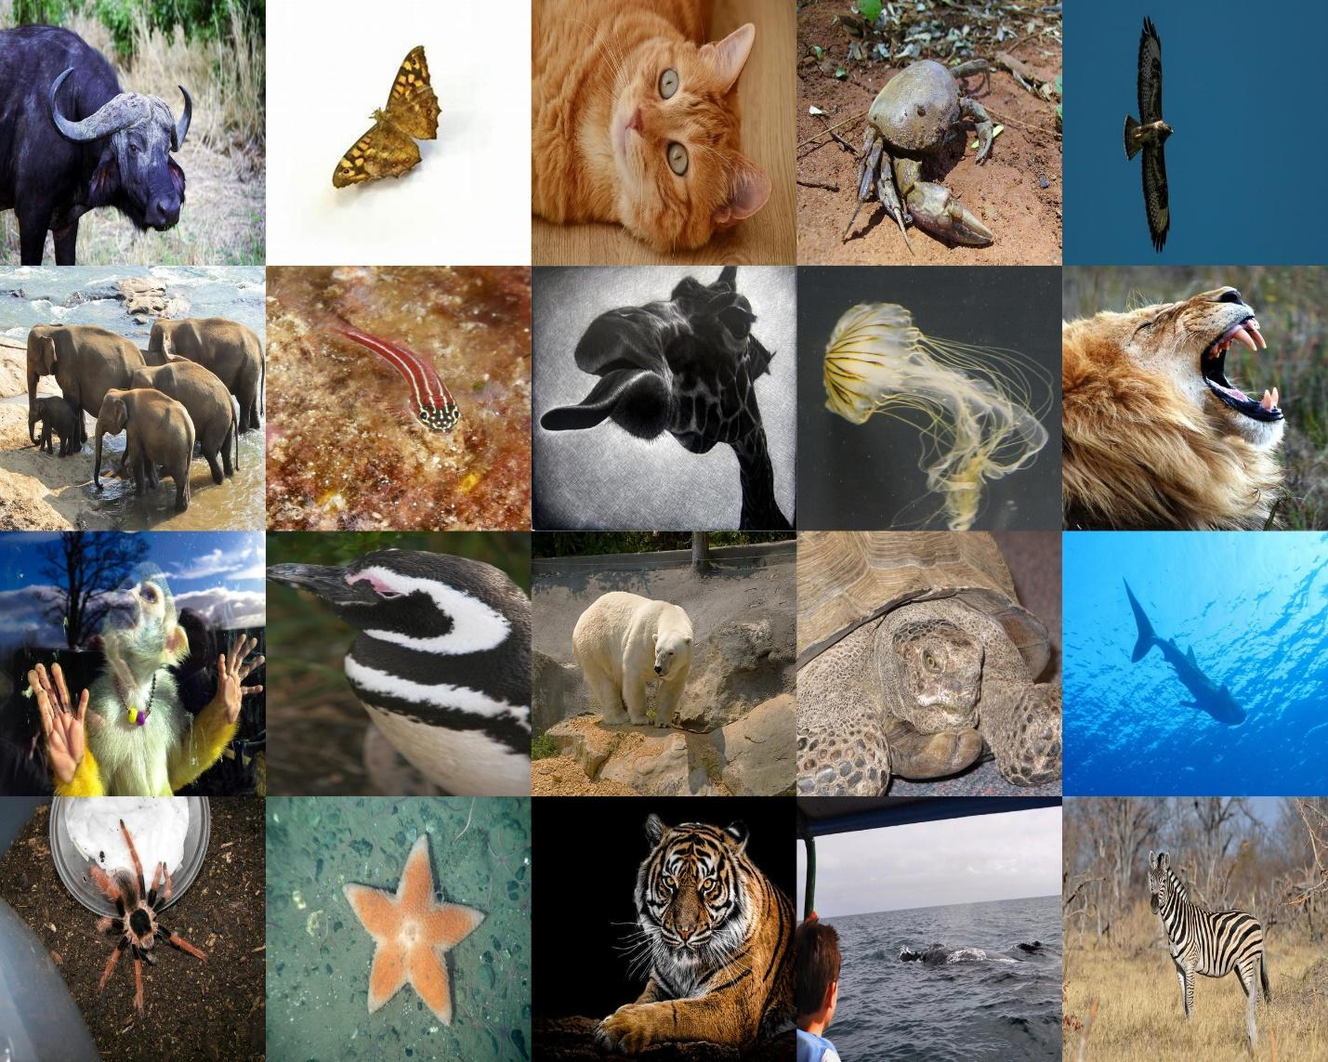
Figure 1: Snapshot of the dataset

Hardware
The Asus 2021 ROG Strix G15 G513IE laptop was used for training and inferences.
The hardware configurations are given below:
- CPU: AMD Ryzen™ 7 4800H (8 Cores, 16 Threads, Max 4.2 GHz)
- GPU: RTX 3050Ti (4 GB VRAM)
- Memory: 32 GB
Estimated hardware usage during training time is given below:
Model | CPU (Utilization % @ GHz) | GPU (GB) | Memory (GB)
ResNet | 73, 4.17 | 1.5 | 11.2
SeNet | 16, 4.00 | 3.3 | 22
Estimated hardware usage during inference time is given below:
Model | CPU (Utilization % @ GHz) | GPU (GB) | Memory (GB)
ResNet | 66, 4.09 | 1.5 | 11.4
SeNet | 14, 3.93 | 3.3 | 21.9
Screenshots of hardware usage during training and inference times are given below:
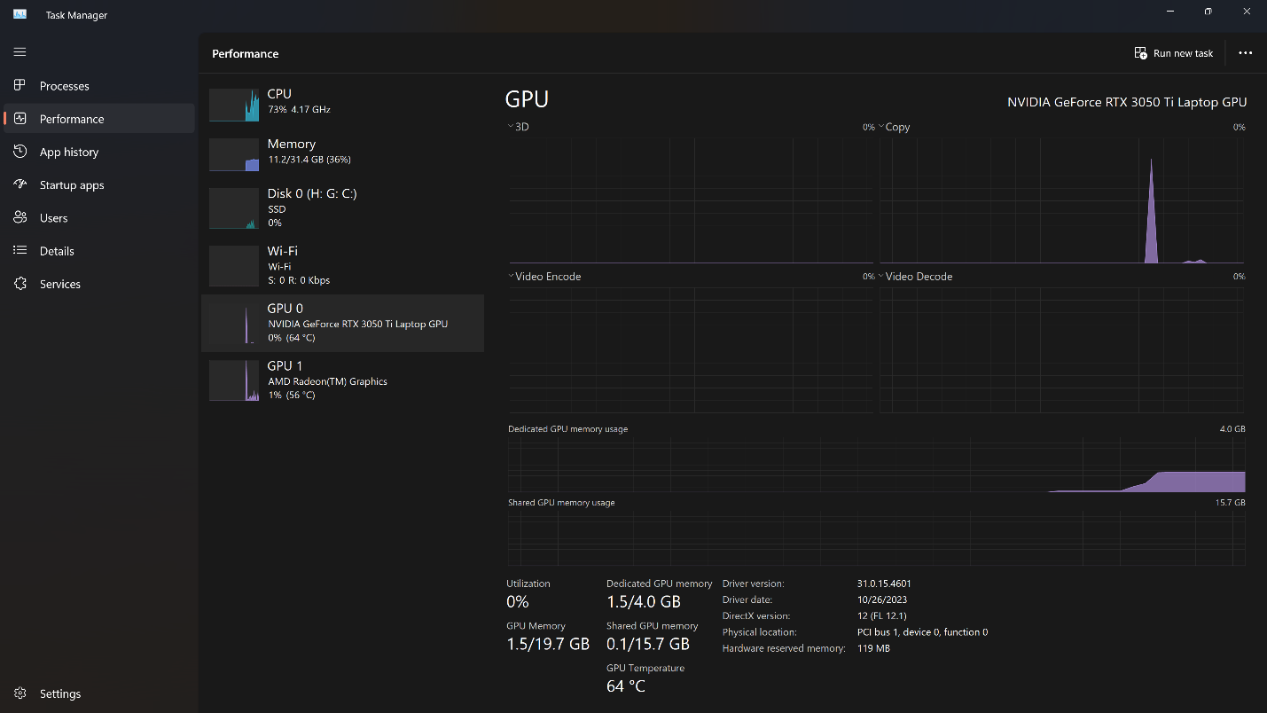
Figure 2: Screenshot of hardware usage during ResNet training.
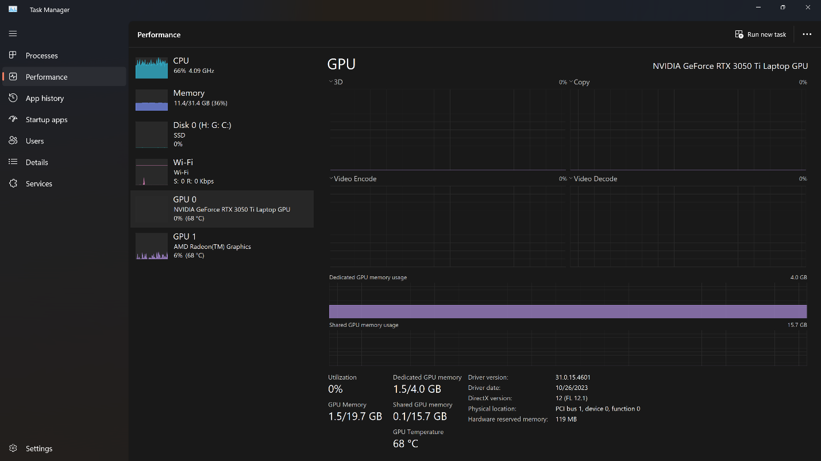
Figure 3: Screenshot of hardware usage during ResNet inference.
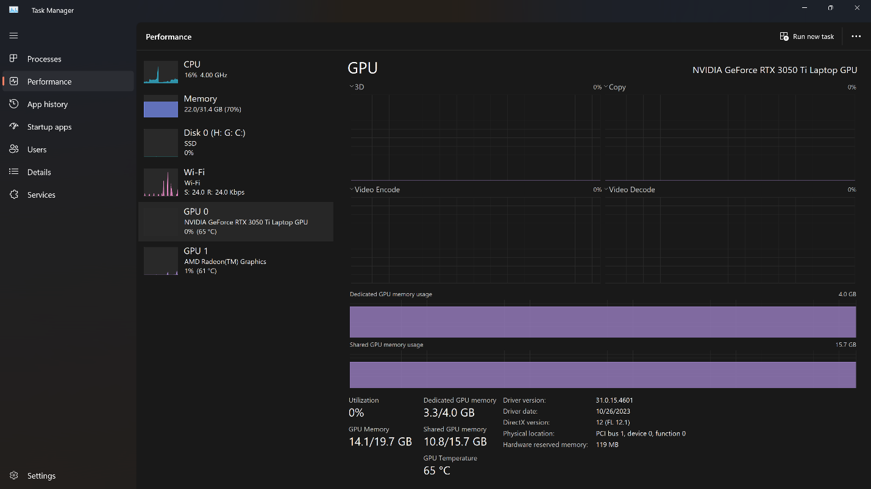
Figure 4: Screenshot of hardware usage during SeNet training.
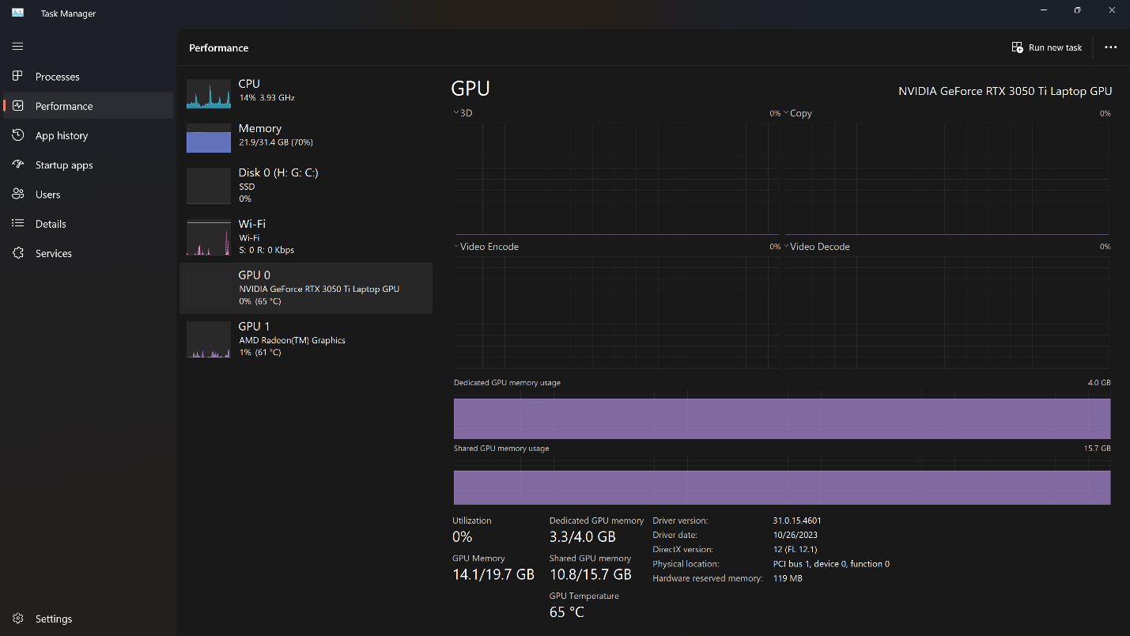
Figure 5: Screenshot of hardware usage during SeNet inference.

Models
The following pre-trained weights from PyTorch have been initialized for the ResNet model:
weights=models.ResNet152_Weights.IMAGENET1K_V2
It is important to note that the entire network, including the FC layers, is considered for calculating the parameters and computations. As the classes 20 are used instead of the default 1000, the parameter count is less than the default. Also, it is to be noted that, as these numbers are for a forward pass, frozen parameters are also included in the transfer learning model. For simplicity, a batch size of 1 is used for the number of calculations instead of 64. As no library functions can find this from PyTorch, a custom function was defined, calculating the floating-point operations (FLOPS), where only basic operations like addition and multiplication are considered. Batch normalization and activations are not included for simplicity.
The following numbers of parameters and computations have been found from PyTorch in each model:
Model | # of parameters | # of computations
ResNet | 58188884 | 3639319461888
SeNet | 64755284 | 901191244447744
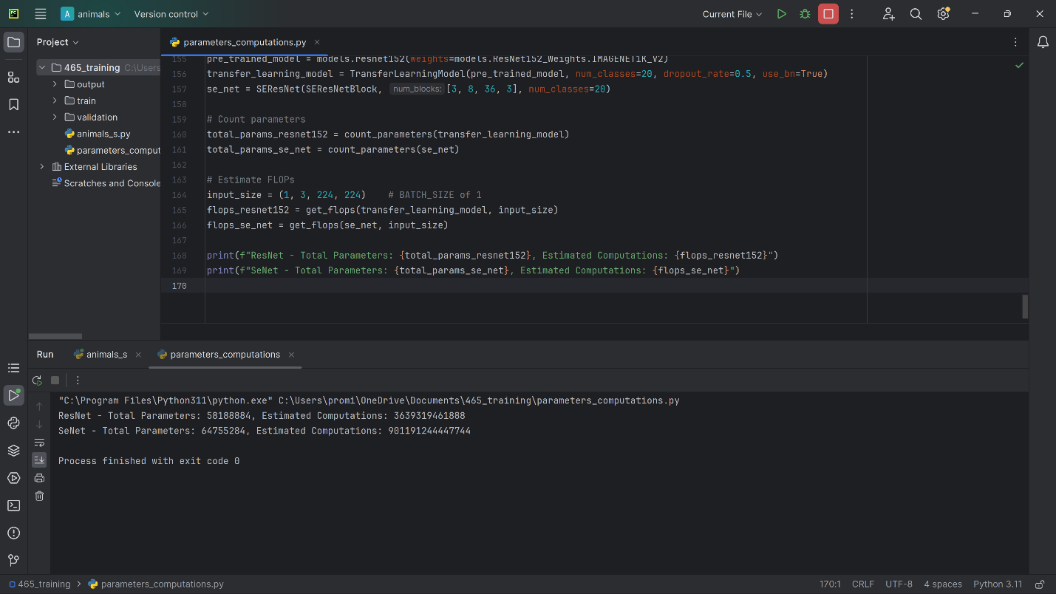
Figure 6: Screenshot of the number of parameters and computations calculation.
The code used to calculate the given values is given below:
import torch
import torch.nn as nn
import torchvision.models as models
class TransferLearningModel(nn.Module):
def __init__(self, base_model, num_classes, dropout_rate, use_bn=False):
super(TransferLearningModel, self).__init__()
self.base_model = base_model
# Freeze the parameters of the pre-trained model
for param in self.base_model.parameters():
param.requires_grad = False
# Replacing the last fully connected layer with a custom classifier
num_features = self.base_model.fc.in_features # Pretrained model features
self.base_model.fc = self._build_classifier(num_features, num_classes, dropout_rate, use_bn)
@staticmethod
def _build_classifier(in_features, num_classes, dropout_rate, use_bn): # FC Layers
layers = [nn.Dropout(dropout_rate)] # DP Layer
if use_bn: # BN Layer
layers.append(nn.BatchNorm1d(in_features))
layers.append(nn.Linear(in_features, num_classes)) # Dense Layer
return nn.Sequential(*layers)
def forward(self, x):
return self.base_model(x)
# Custom SELayer definition
class SELayer(nn.Module):
def __init__(self, channel, reduction=16):
super(SELayer, self).__init__()
self.avg_pool = nn.AdaptiveAvgPool2d(1)
self.fc = nn.Sequential(
nn.Linear(channel, channel // reduction, bias=False),
nn.ReLU(inplace=True),
nn.Linear(channel // reduction, channel, bias=False),
nn.Sigmoid()
)
def forward(self, x):
b, c, _, _ = x.size()
y = self.avg_pool(x).view(b, c)
y = self.fc(y).view(b, c, 1, 1)
return x * y.expand_as(x)
# Custom SEResNetBlock definition
class SEResNetBlock(nn.Module):
expansion = 4
def __init__(self, in_planes, planes, stride=1, reduction=16):
super(SEResNetBlock, self).__init__()
self.conv1 = nn.Conv2d(in_planes, planes, kernel_size=1, bias=False)
self.bn1 = nn.BatchNorm2d(planes)
self.conv2 = nn.Conv2d(planes, planes, kernel_size=3, stride=stride, padding=1, bias=False)
self.bn2 = nn.BatchNorm2d(planes)
self.conv3 = nn.Conv2d(planes, self.expansion * planes, kernel_size=1, bias=False)
self.bn3 = nn.BatchNorm2d(self.expansion * planes)
self.se = SELayer(self.expansion * planes, reduction)
self.shortcut = nn.Sequential()
if stride != 1 or in_planes != self.expansion * planes:
self.shortcut = nn.Sequential(
nn.Conv2d(in_planes, self.expansion * planes, kernel_size=1, stride=stride, bias=False),
nn.BatchNorm2d(self.expansion * planes)
)
def forward(self, x):
out = nn.ReLU()(self.bn1(self.conv1(x)))
out = nn.ReLU()(self.bn2(self.conv2(out)))
out = self.bn3(self.conv3(out))
out = self.se(out)
out += self.shortcut(x)
out = nn.ReLU()(out)
return out
# Custom SEResNet model definition
class SEResNet(nn.Module):
def __init__(self, block, num_blocks, num_classes=1000):
super(SEResNet, self).__init__()
self.in_planes = 64
self.conv1 = nn.Conv2d(3, 64, kernel_size=3, stride=1, padding=1, bias=False)
self.bn1 = nn.BatchNorm2d(64)
self.layer1 = self._make_layer(block, 64, num_blocks[0], stride=1)
self.layer2 = self._make_layer(block, 128, num_blocks[1], stride=2)
self.layer3 = self._make_layer(block, 256, num_blocks[2], stride=2)
self.layer4 = self._make_layer(block, 512, num_blocks[3], stride=2)
self.linear = nn.Linear(512 * block.expansion, num_classes)
def _make_layer(self, block, planes, num_blocks, stride):
strides = [stride] + [1] * (num_blocks - 1)
layers = []
for stride in strides:
layers.append(block(self.in_planes, planes, stride))
self.in_planes = planes * block.expansion
return nn.Sequential(*layers)
def forward(self, x):
out = nn.ReLU()(self.bn1(self.conv1(x)))
out = self.layer1(out)
out = self.layer2(out)
out = self.layer3(out)
out = self.layer4(out)
out = nn.AdaptiveAvgPool2d((1, 1))(out)
out = out.view(out.size(0), -1)
out = self.linear(out)
return out
# Function to count parameters
def count_parameters(model):
return sum(p.numel() for p in model.parameters())
# Function to estimate FLOPs
def get_flops(model, input_dim):
model.eval()
device = next(model.parameters()).device # Get the device of the model
flops = torch.tensor([0.0], device=device)
def add_hooks(module):
if len(list(module.children())) > 0:
return
module.register_forward_hook(hook)
def hook(module, input0, output):
input0 = input0[0]
output = output[0]
batch_size = input0.shape[0]
output_elements = output.numel()
input_elements = input0.numel()
flops_per_element = 2 # Assuming multiply-add operations
if isinstance(module, (nn.Conv2d, nn.Linear)):
flops_per_element = input_elements // batch_size
flops.add_(batch_size * output_elements * flops_per_element)
model.apply(add_hooks)
dummy_input = torch.randn(input_dim)
model(dummy_input.to(device))
return int(flops.item())
# Models
pre_trained_model = models.resnet152(weights=models.ResNet152_Weights.IMAGENET1K_V2)
transfer_learning_model = TransferLearningModel(pre_trained_model, num_classes=20, dropout_rate=0.5, use_bn=True)
se_net = SEResNet(SEResNetBlock, [3, 8, 36, 3], num_classes=20)
# Count parameters
total_params_resnet152 = count_parameters(transfer_learning_model)
total_params_se_net = count_parameters(se_net)
# Estimate FLOPs
input_size = (1, 3, 224, 224) # BATCH_SIZE of 1
flops_resnet152 = get_flops(transfer_learning_model, input_size)
flops_se_net = get_flops(se_net, input_size)
print(f"ResNet - Total Parameters: {total_params_resnet152}, Estimated Computations: {flops_resnet152}")
print(f"SeNet - Total Parameters: {total_params_se_net}, Estimated Computations: {flops_se_net}")

Metric
It is important to note that the average weighted recall was used for recall calculation.
ResNet’s performance metrics are given below:
Dropout | Batch Normalization | Epoch | Accuracy | Precision | Recall
0.0 | False | 121 | 0.975 | 0.975133335 | 0.975
0.0 | True | 087 | 0.964 | 0.964099568 | 0.964
0.2 | False | 138 | 0.975 | 0.975369150 | 0.975
0.2 | True | 087 | 0.966 | 0.966406526 | 0.966
0.3 | False | 127 | 0.974 | 0.974438370 | 0.974
0.3 | True | 090 | 0.971 | 0.971513341 | 0.971
0.4 | False | 117 | 0.969 | 0.969339367 | 0.969
0.4 | True | 108 | 0.967 | 0.967104320 | 0.967
0.5 | False | 156 | 0.973 | 0.973155326 | 0.973
0.5 | True | 095 | 0.965 | 0.965096725 | 0.965
SeNet’s performance metrics are given below:
Dropout | Batch Normalization | Epoch | Accuracy | Precision | Recall
0.0 | False | 28 | 0.488 | 0.513466274 | 0.488
0.0 | True | 34 | 0.496 | 0.498935088 | 0.496
0.2 | False | 40 | 0.524 | 0.545607366 | 0.524
0.2 | True | 30 | 0.504 | 0.517430346 | 0.504
0.3 | False | 42 | 0.539 | 0.544515670 | 0.539
0.3 | True | 41 | 0.536 | 0.550808151 | 0.536
0.4 | False | 33 | 0.490 | 0.529336000 | 0.490
All the confusion matrices are given below:
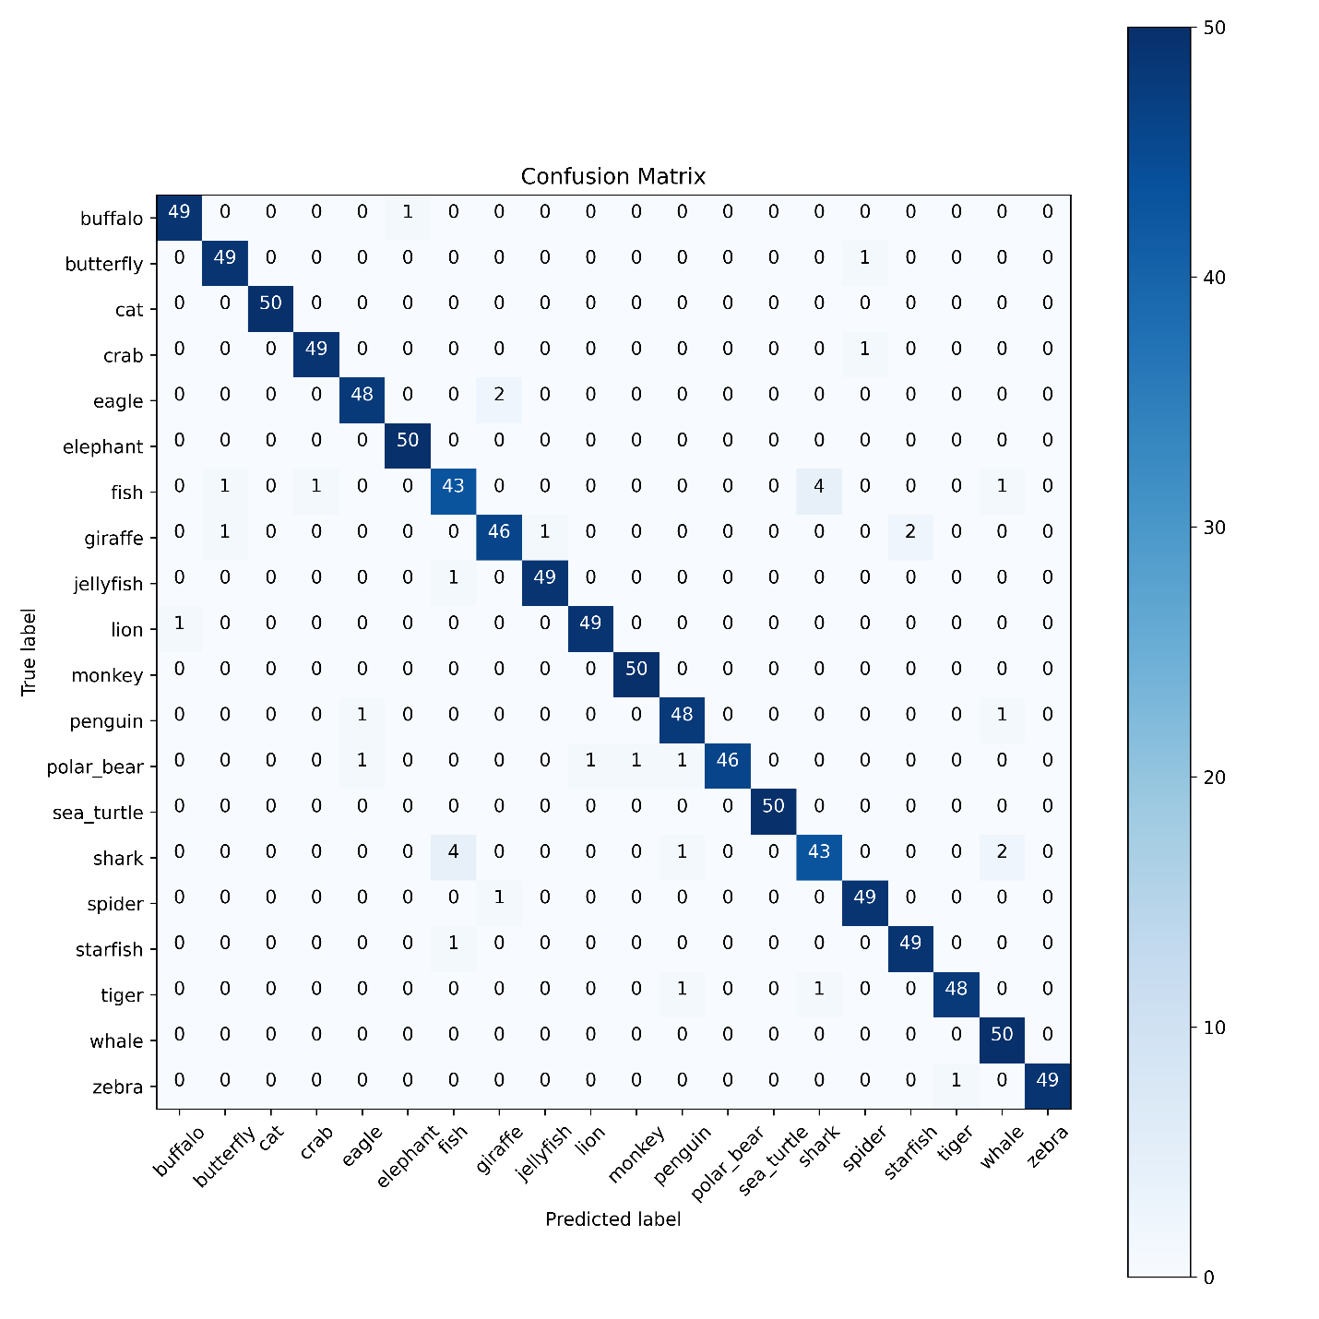
Figure 7: ResNet Dropout: 0.0, BN: False
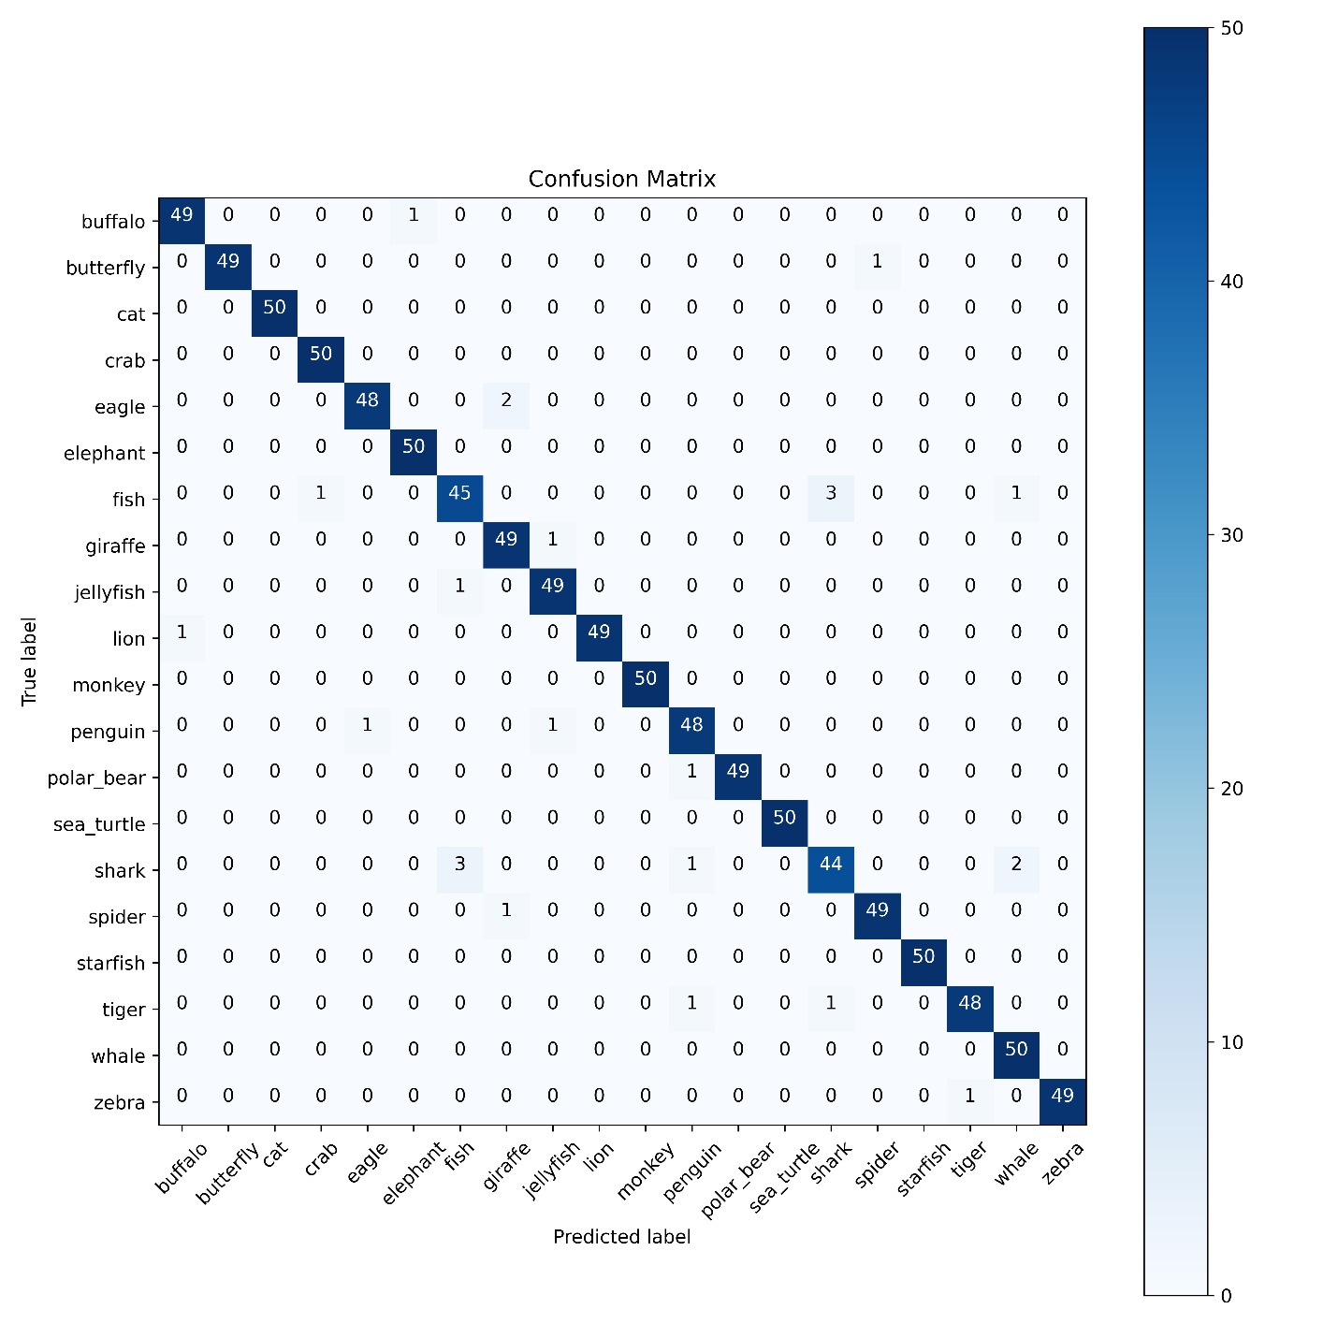
Figure 8: ResNet Dropout: 0.0, BN: True
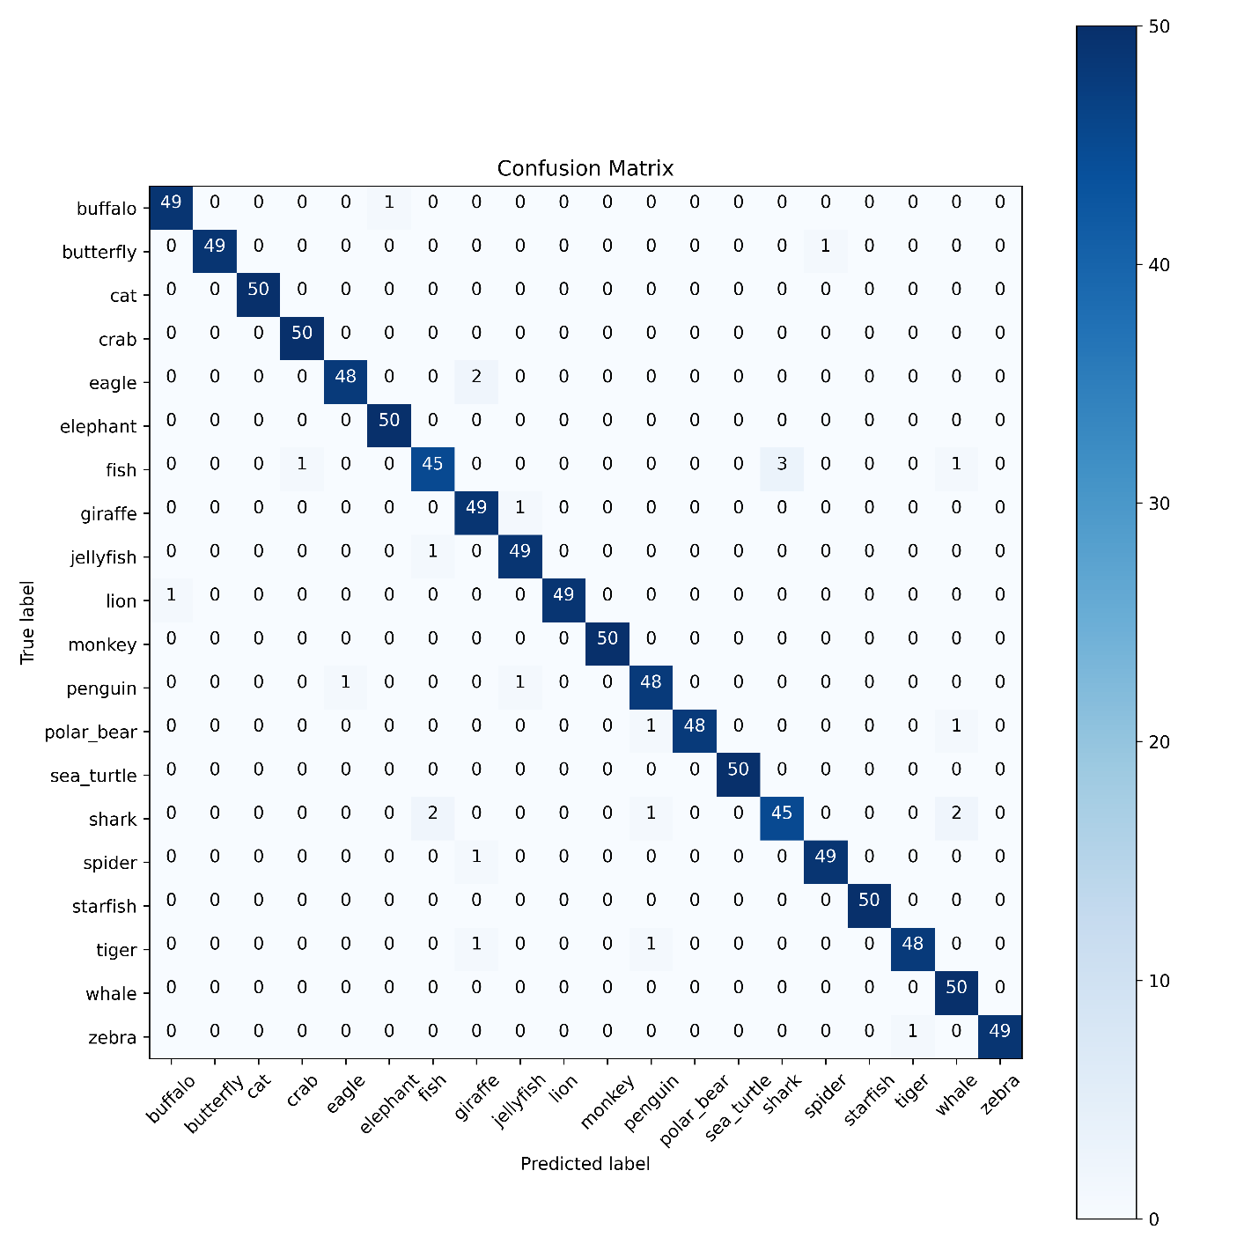
Figure 9: ResNet Dropout: 0.2, BN: False
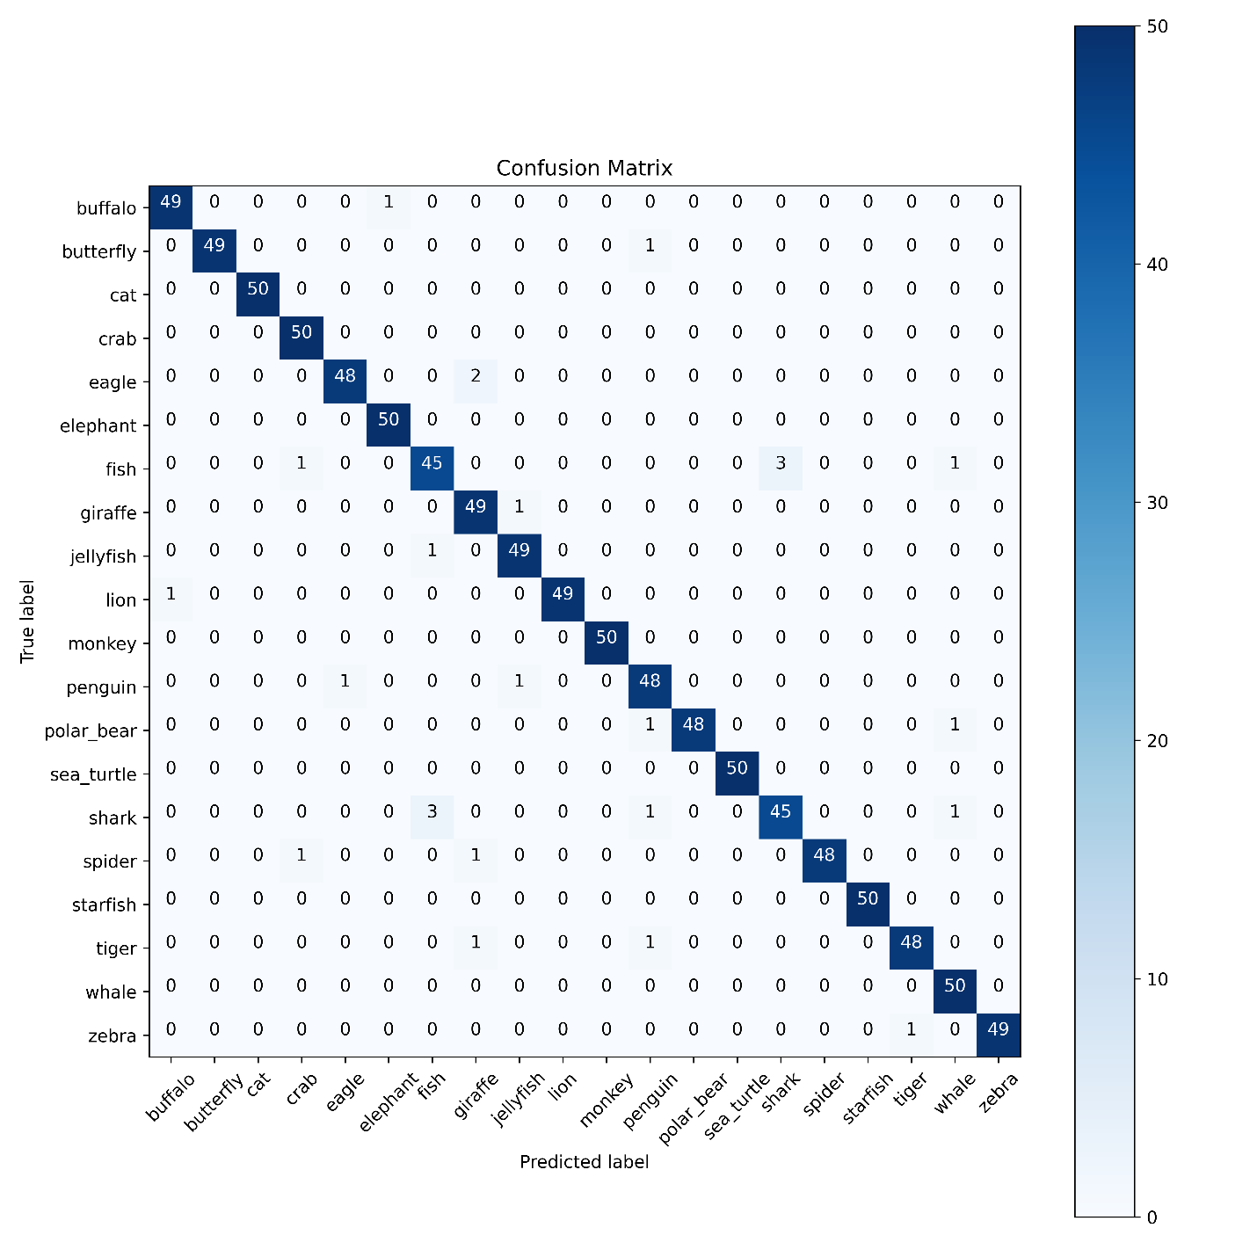
Figure 10: ResNet Dropout: 0.2, BN: True
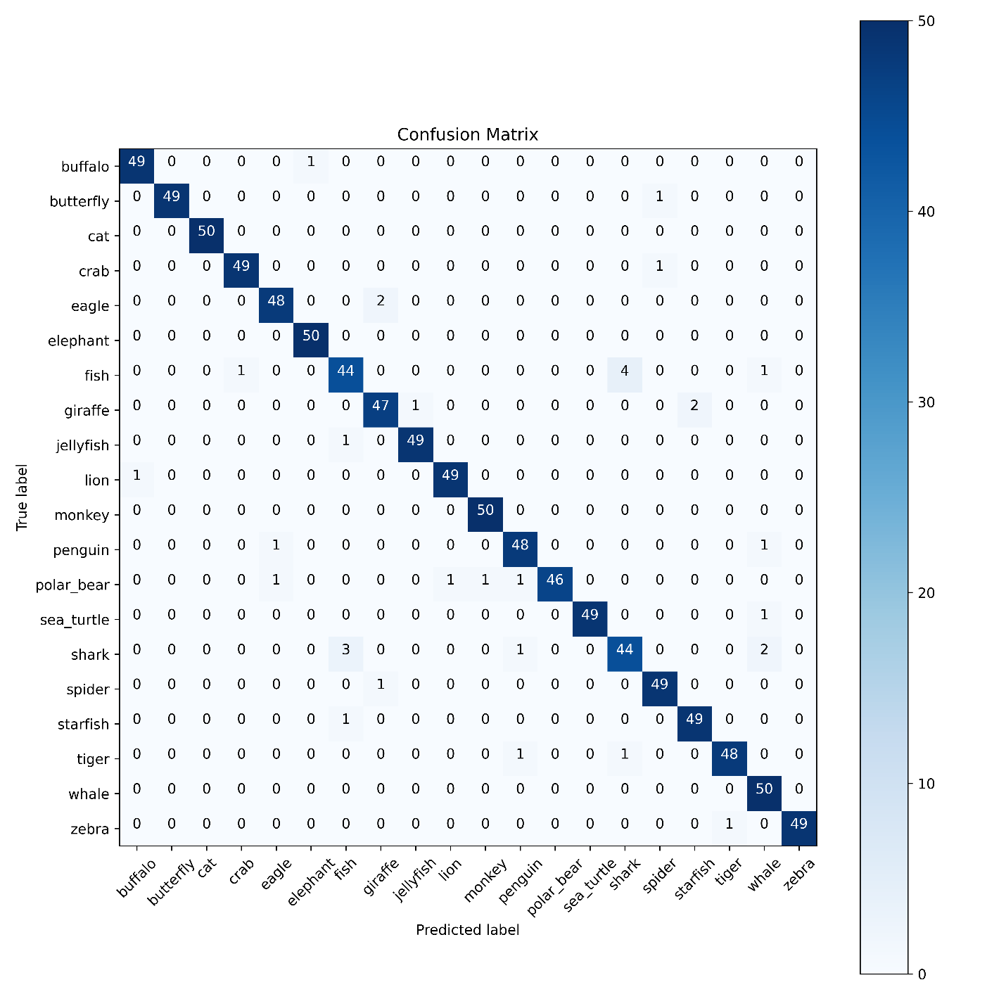
Figure 11: ResNet Dropout: 0.3, BN: False
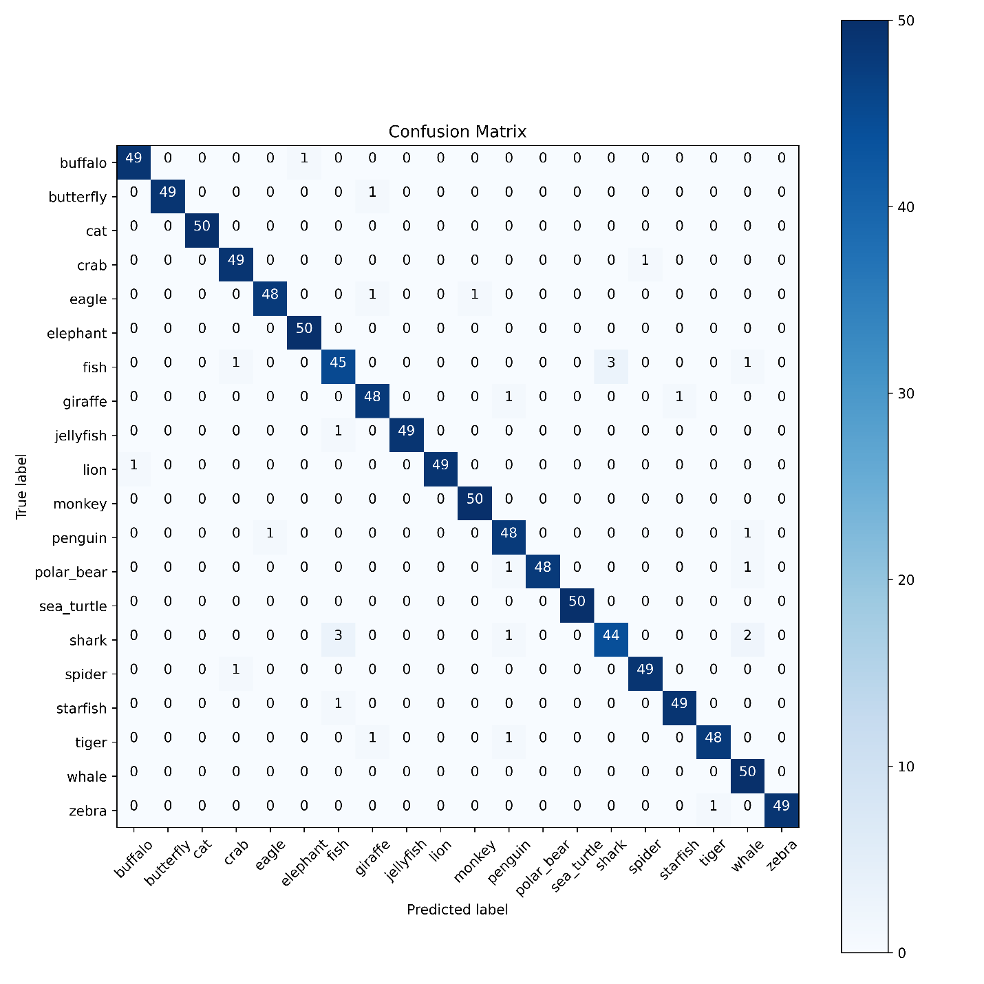
Figure 12: ResNet Dropout: 0.3, BN: True
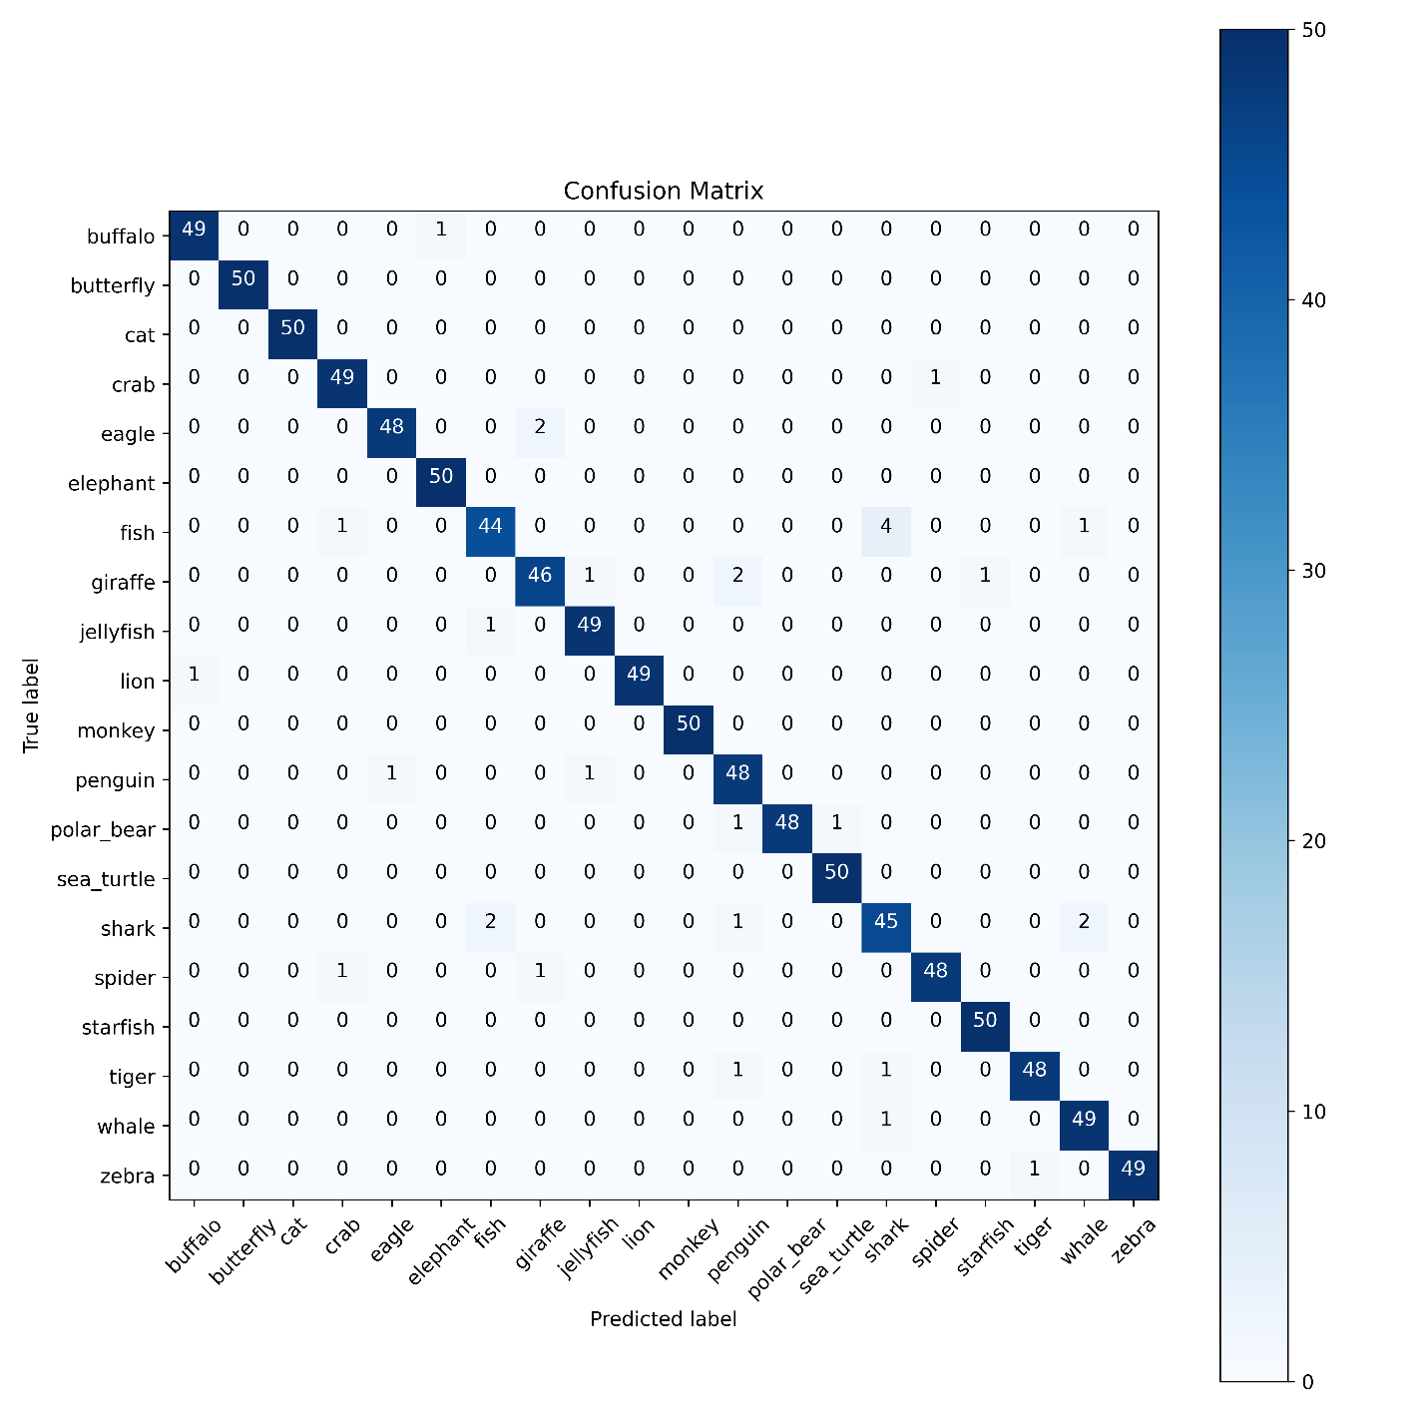
Figure 13: ResNet Dropout: 0.4, BN: False
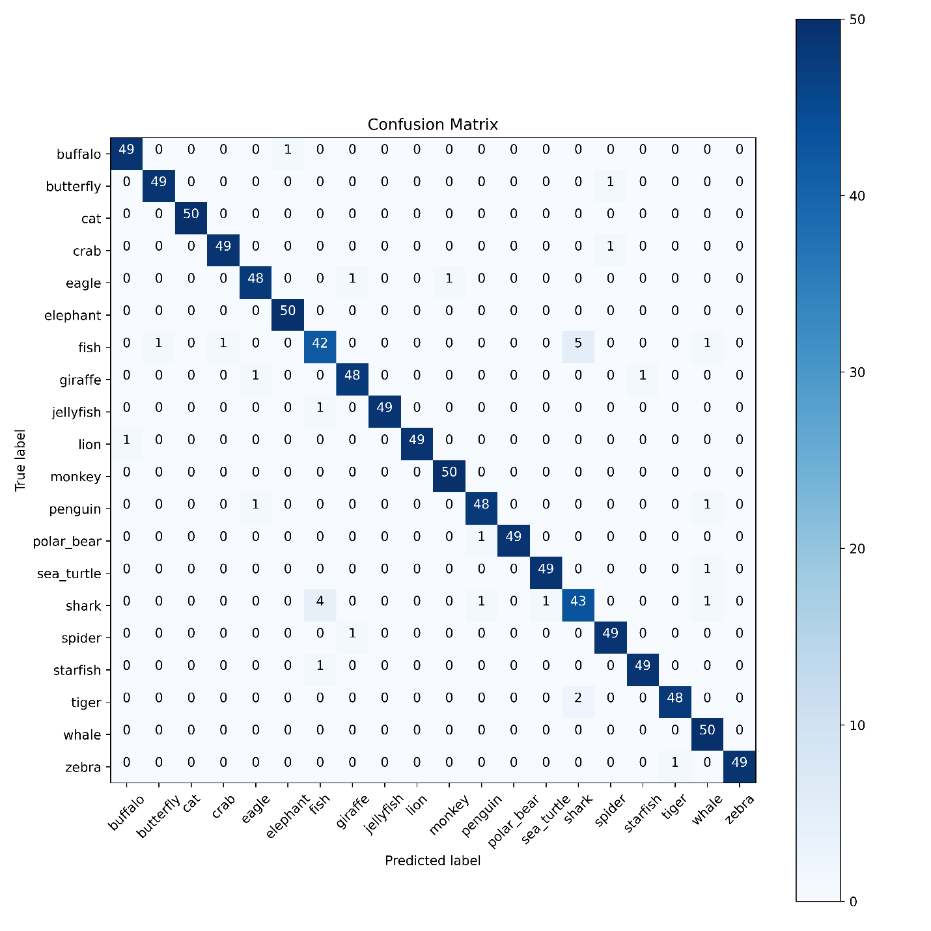
Figure 14: ResNet Dropout: 0.4, BN: True
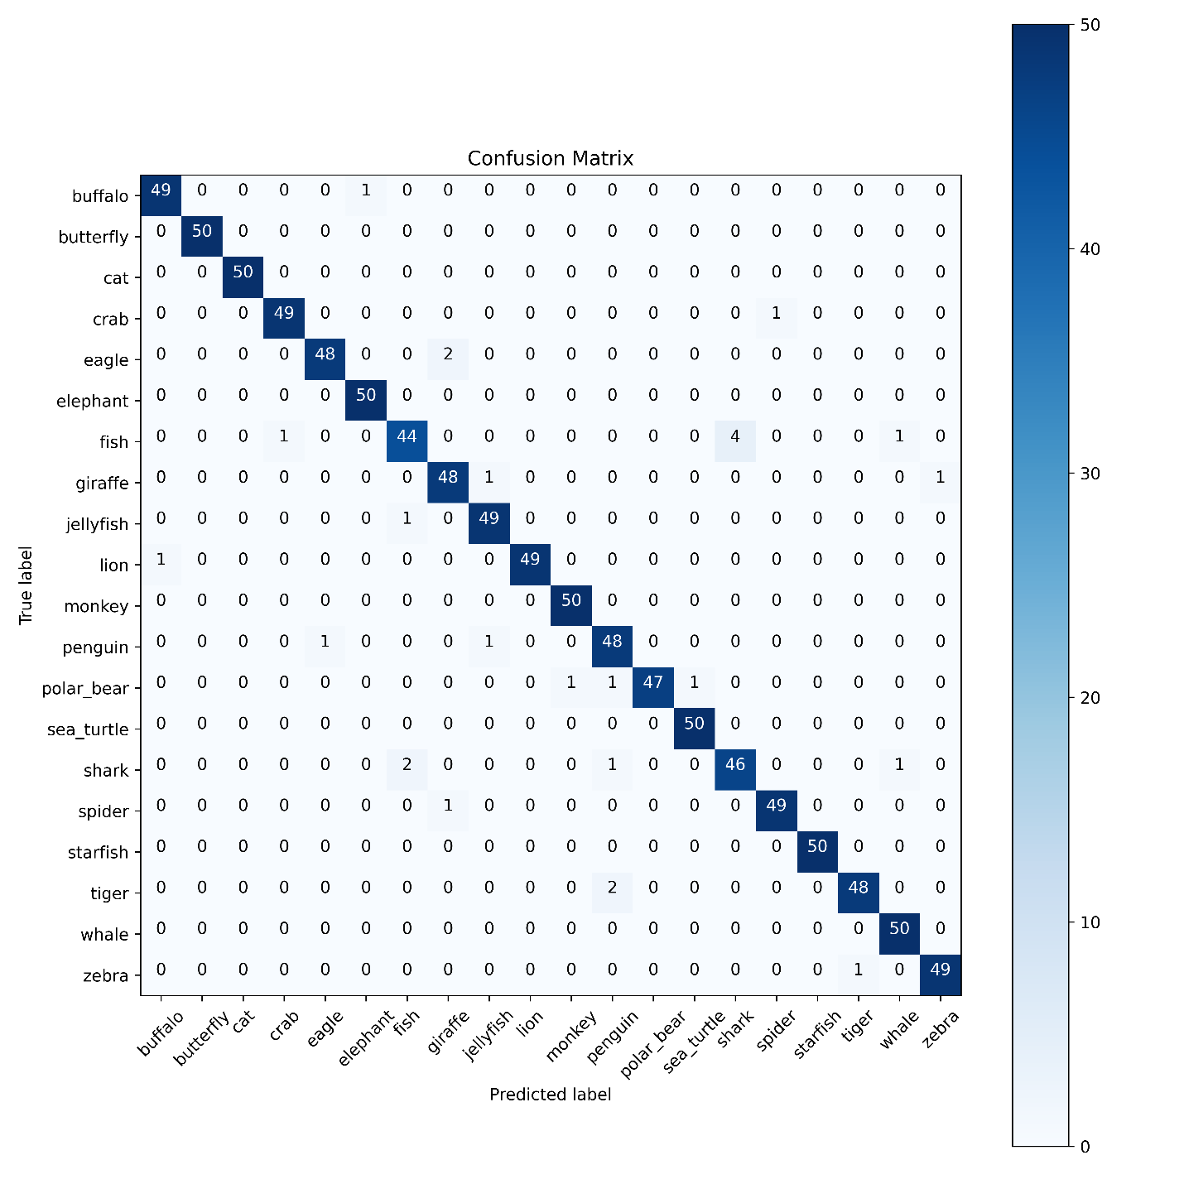
Figure 15: ResNet Dropout: 0.5, BN: False
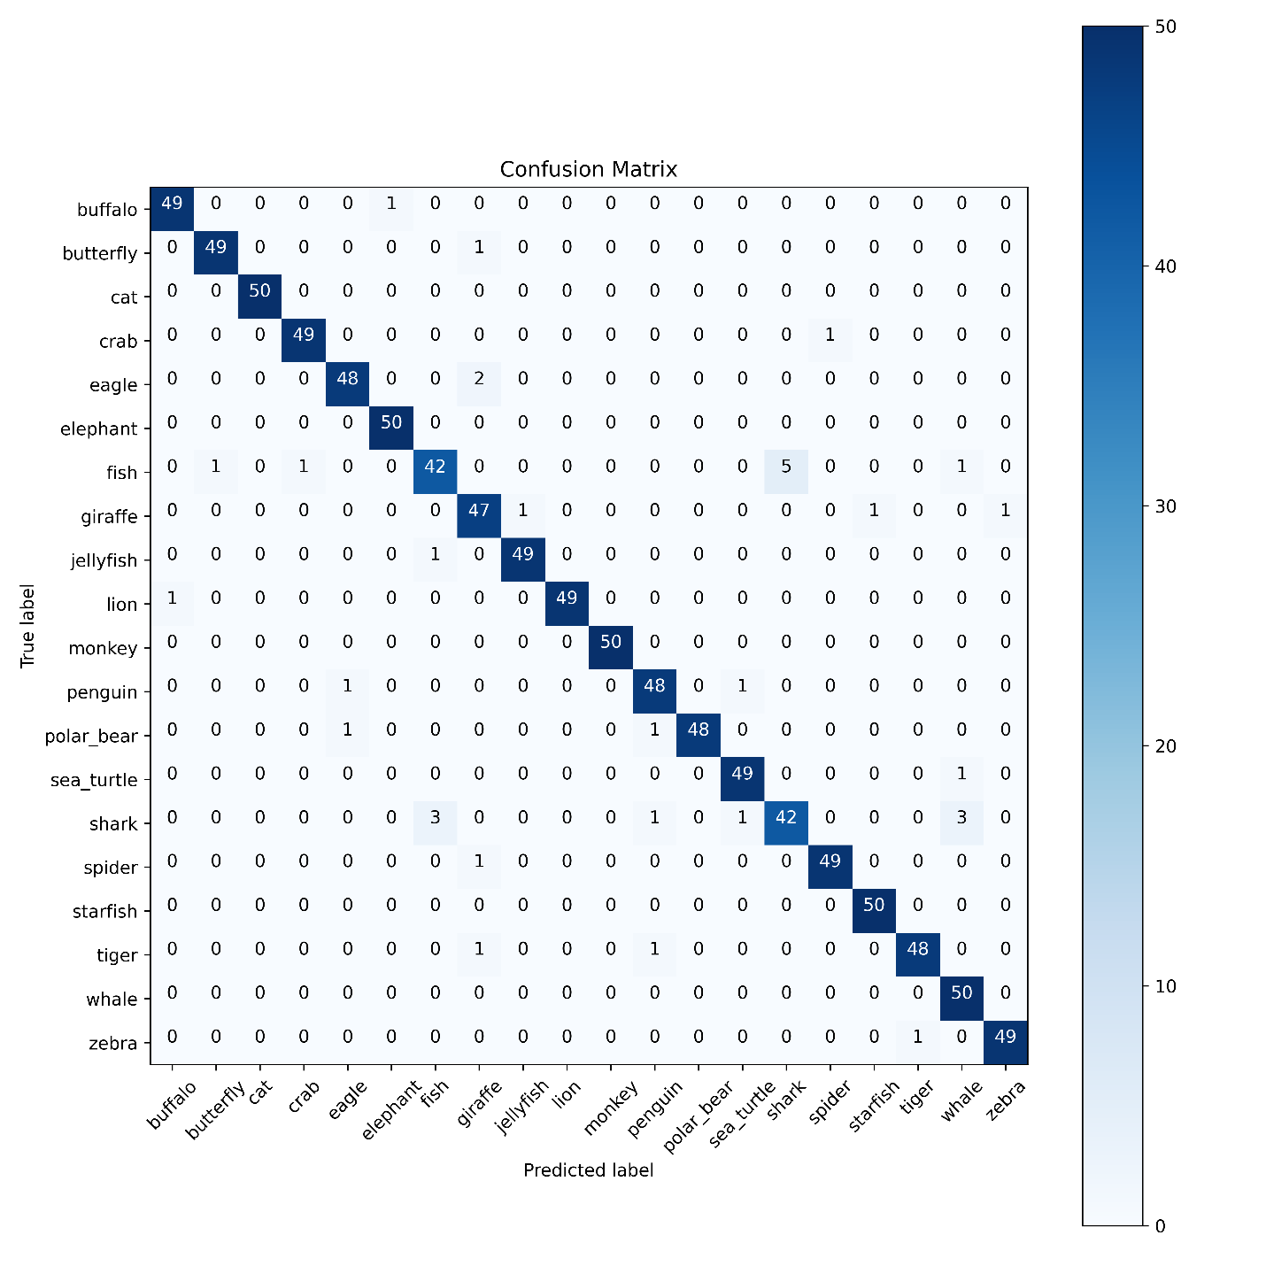
Figure 16: ResNet Dropout: 0.5, BN: True

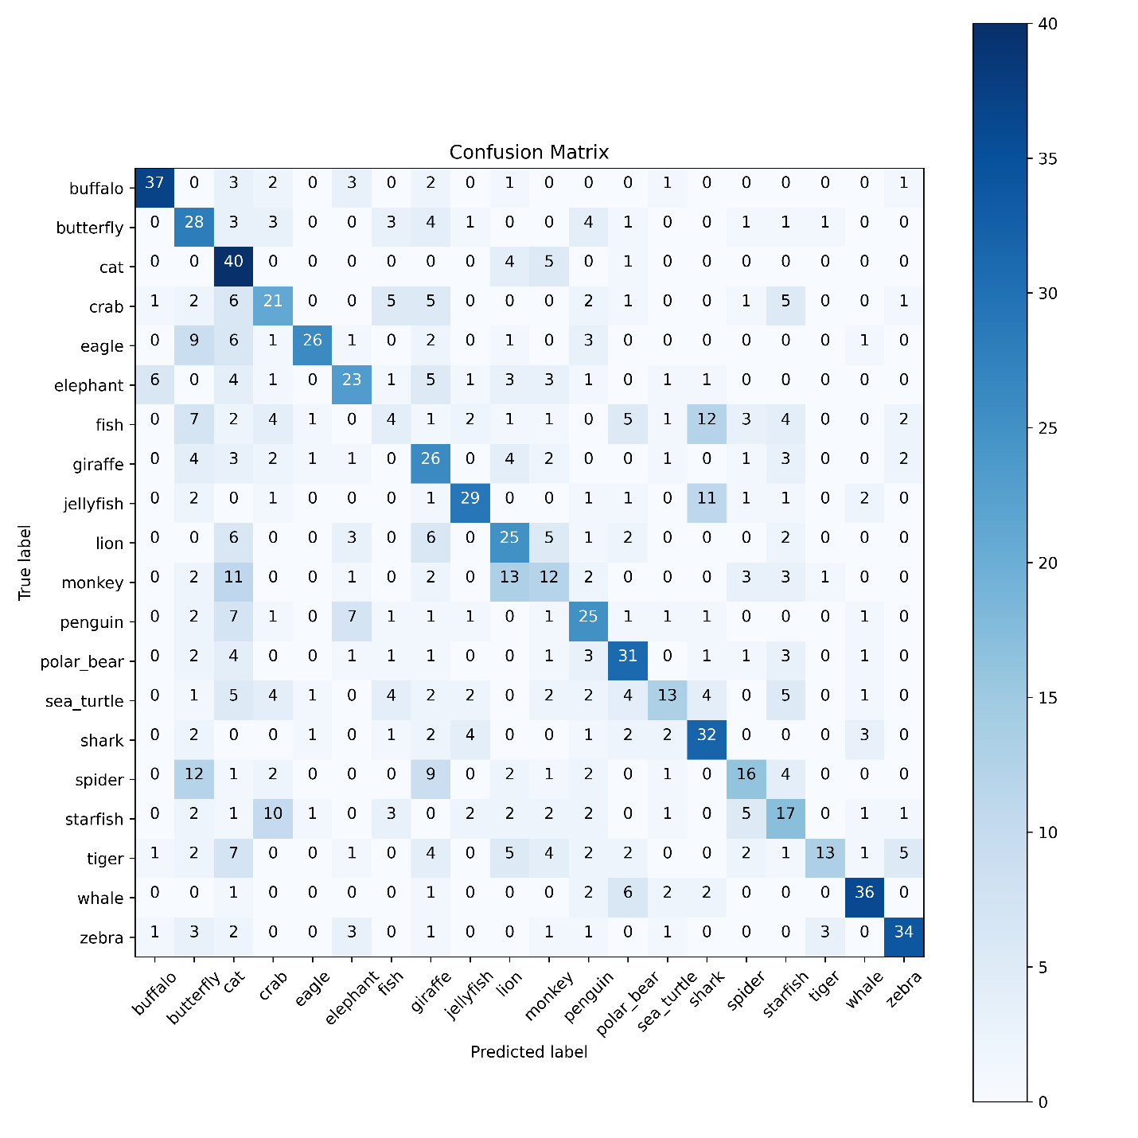
Figure 17: SeNet Dropout: 0.0, BN: False
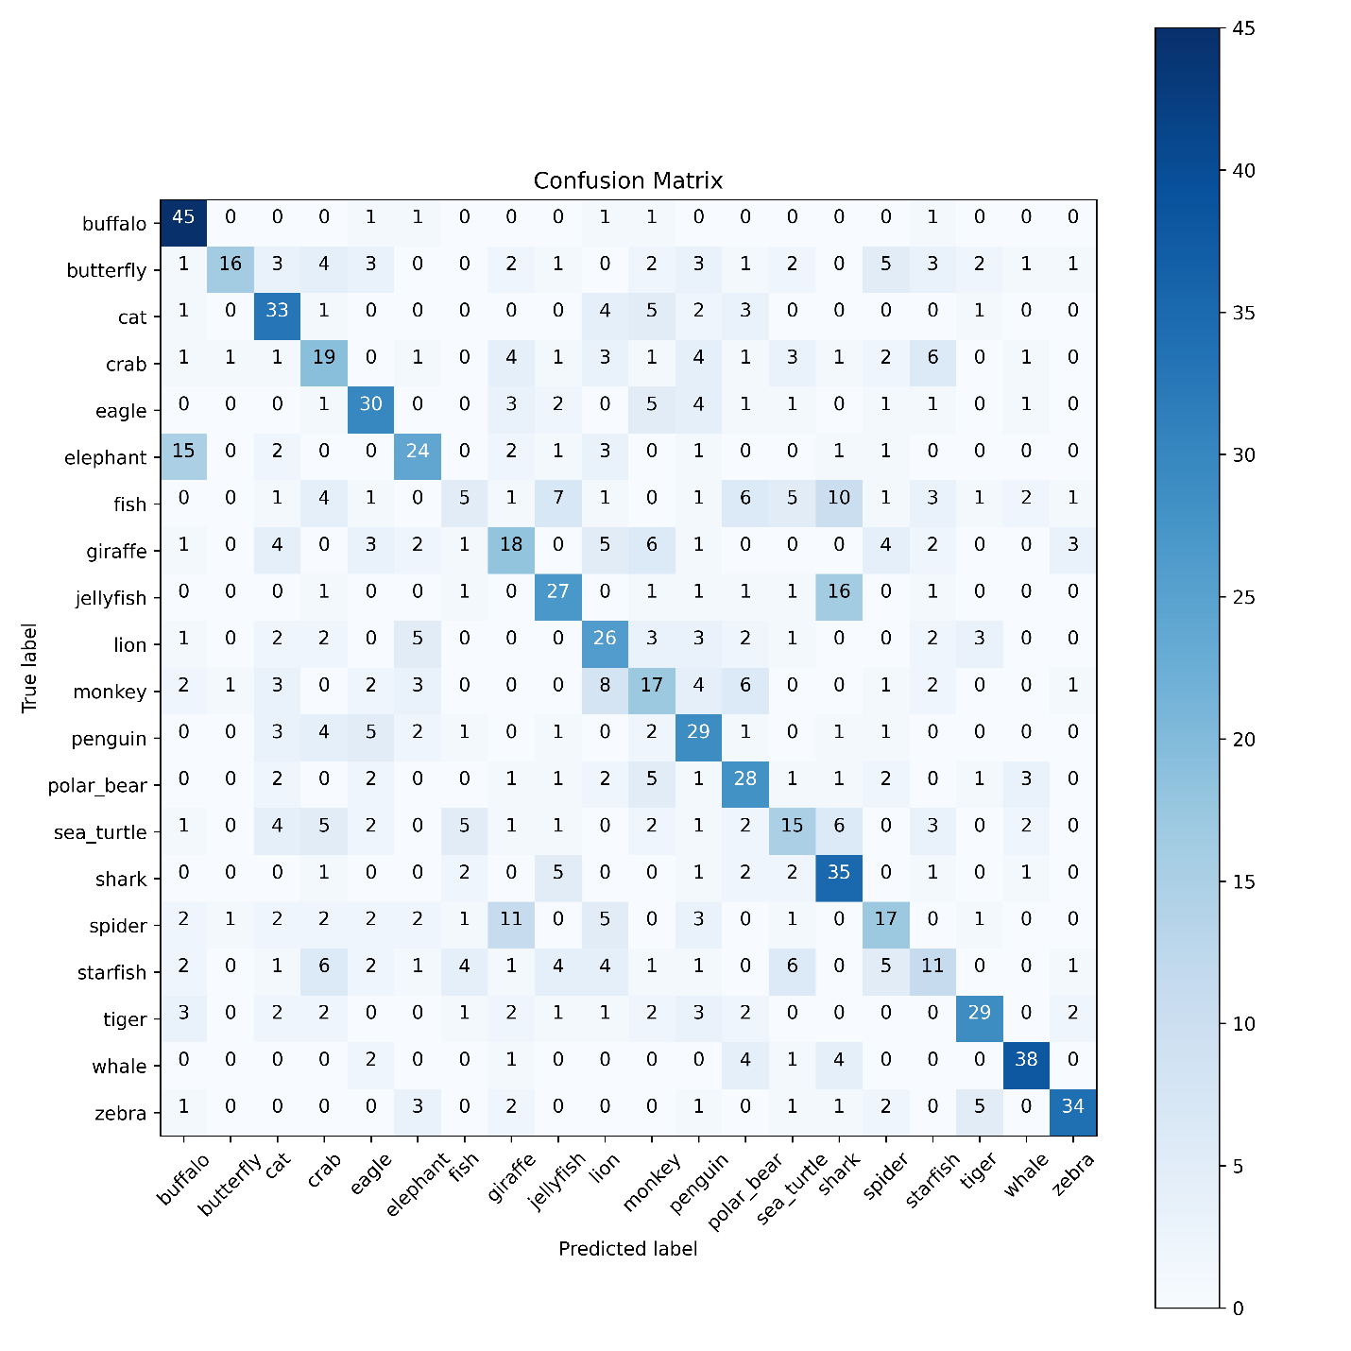
Figure 18: SeNet Dropout: 0.0, BN: True
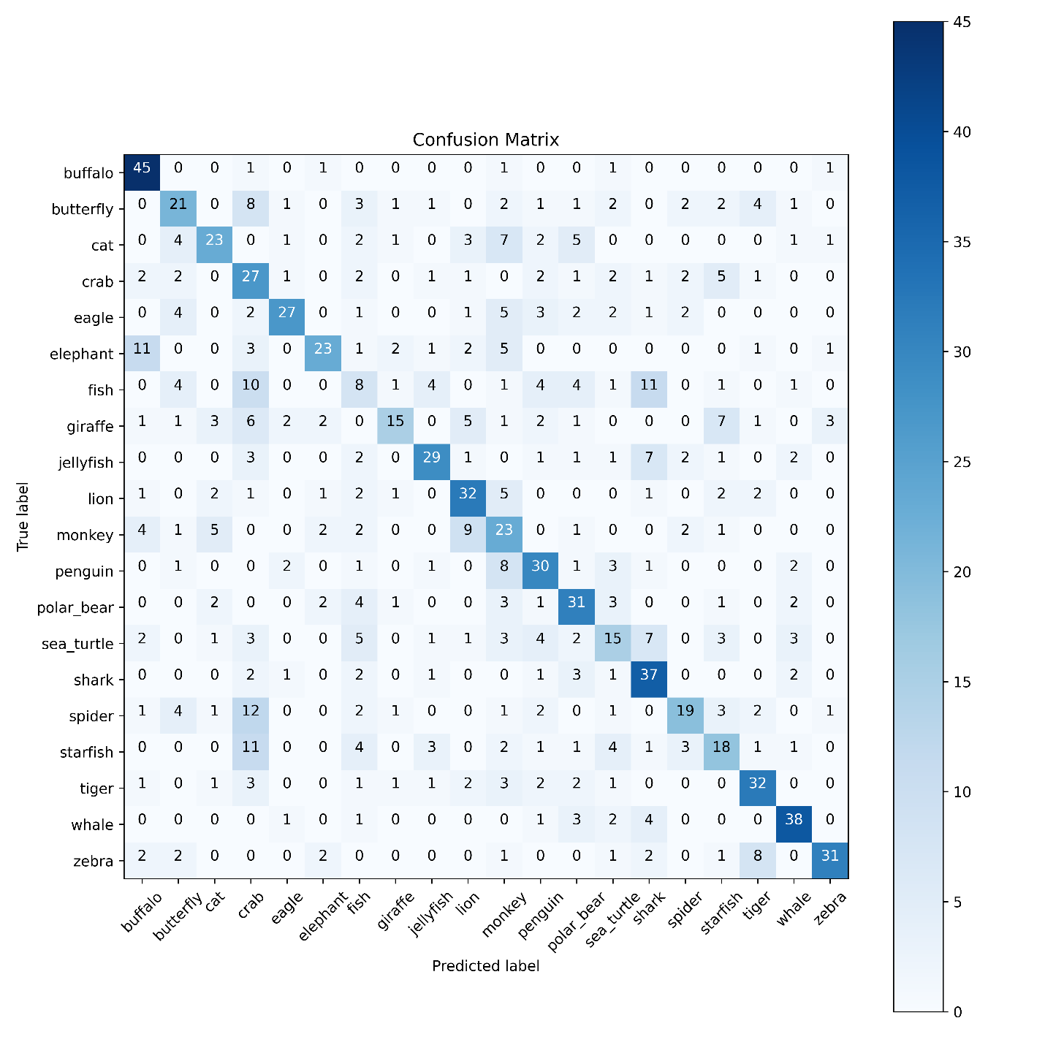
Figure 19: SeNet Dropout: 0.2, BN: False
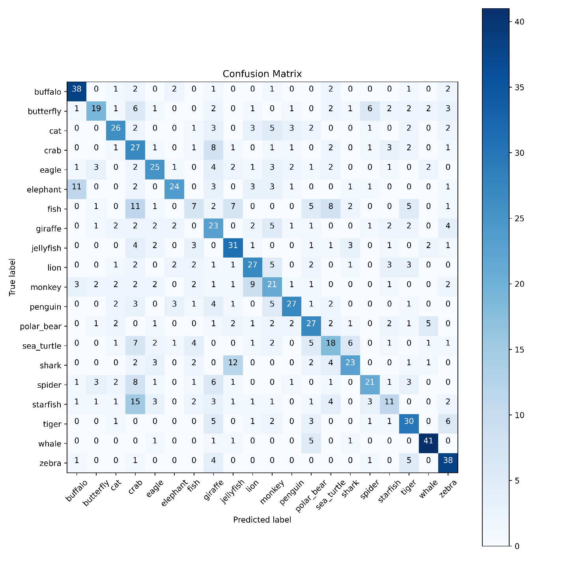
Figure 20: SeNet Dropout: 0.2, BN: True
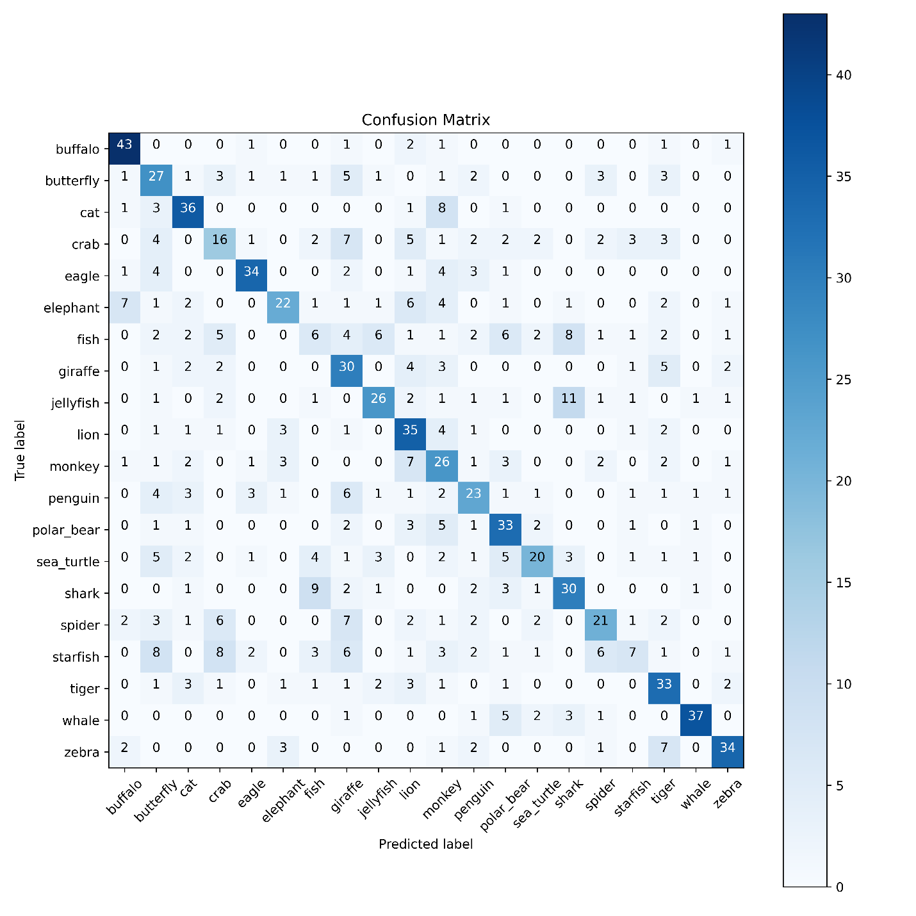
Figure 21: SeNet Dropout: 0.3, BN: False
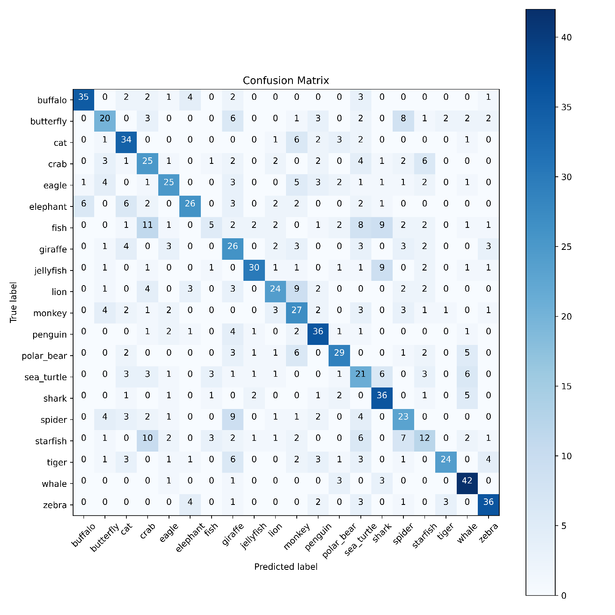
Figure 22: SeNet Dropout: 0.3, BN: True
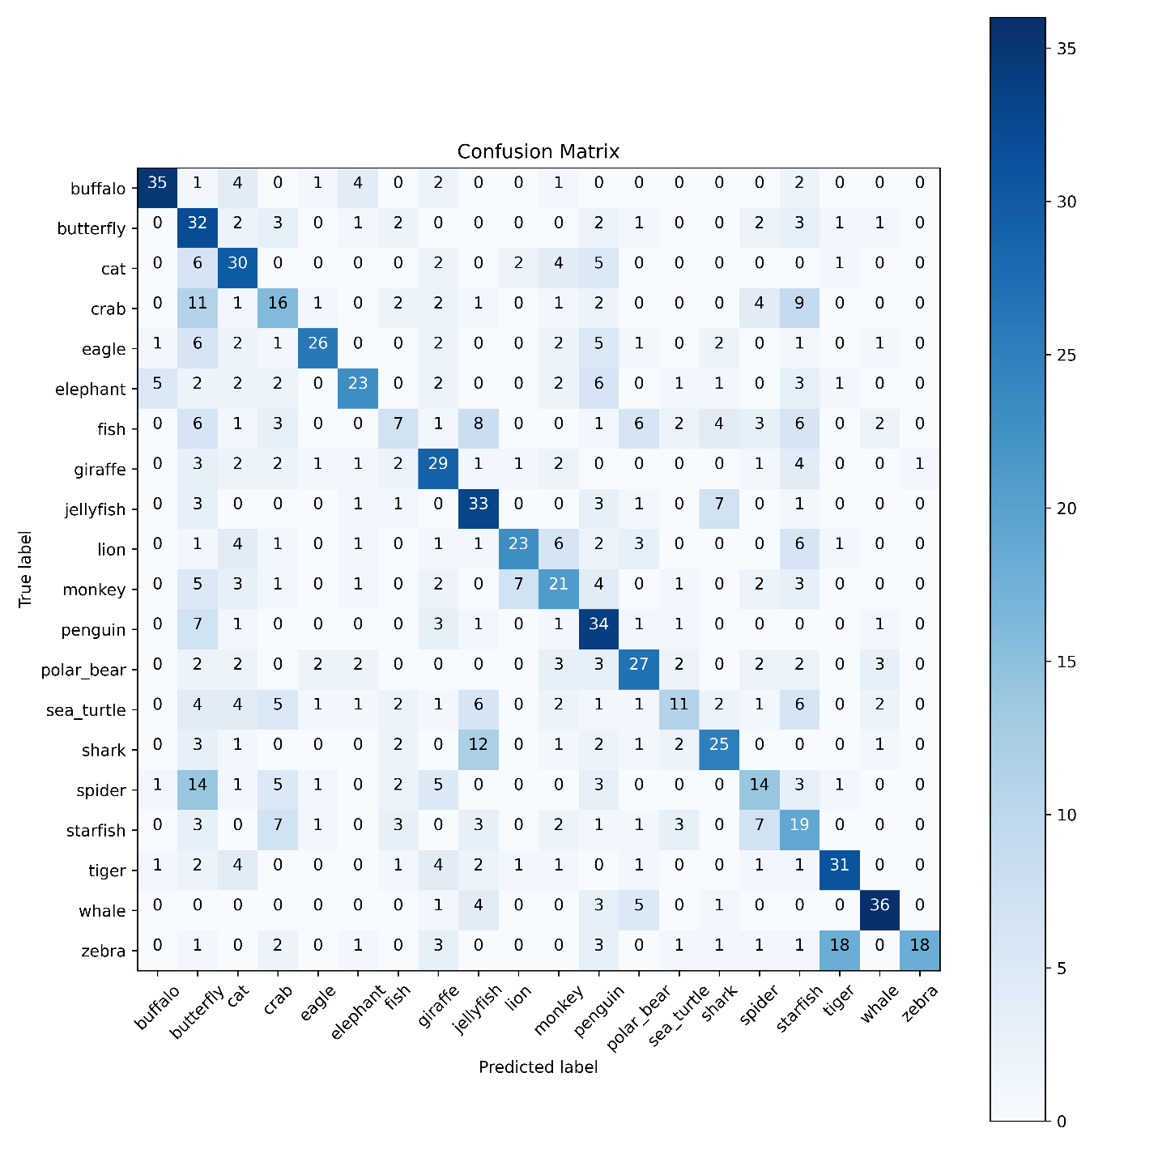
Figure 23: SeNet Dropout: 0.4, BN: False

